The menu bar contains the company logo in the upper left corner. which is a common location for a website logo, due to the fact that people often read from left to right, and automatically look at the upper left corner first. (<https://www.nngroup.com/articles/logo-placement-brand-recall/>)

To the right of the logo, the first menu button leads to the booking site. The button is titled:’ Get ticket’ to state that there is an upcoming action for the user, also called a ‘call to action-button’. For the user to acknowledge this, the design has to be modified to attract the user to the button. The position of the button could either be next to the logo, on the far right or underneath the menu bar in the ‘Event informations’ box.

Blog:

The second button will lead the user to the website blog.

About:

Contact:

Event information:

Underneath the menu bar is a non clickable bar with information about the upcoming event. As it is today, the monthly

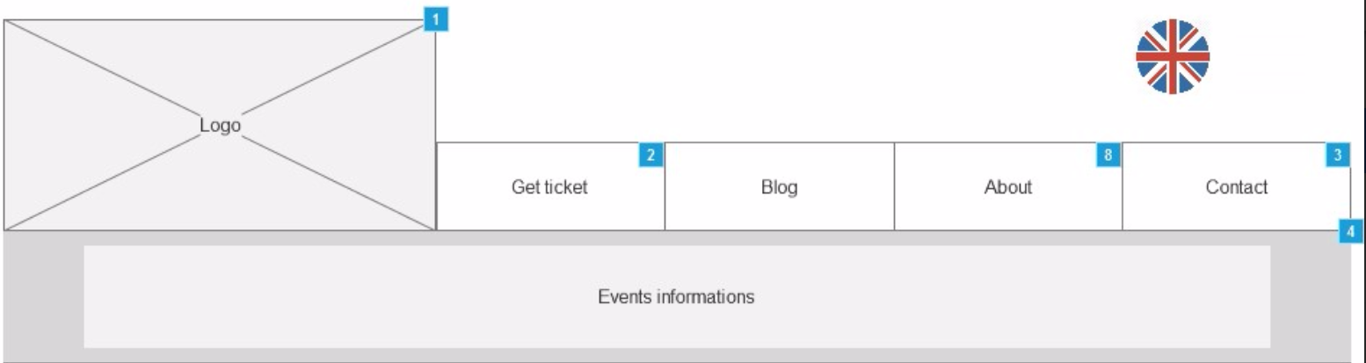

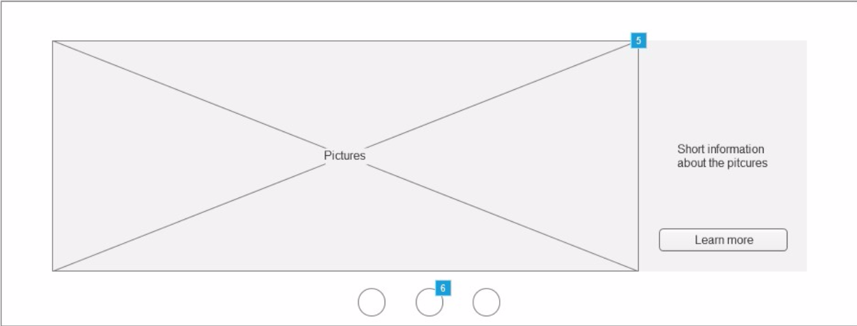

The company host a monthly social event, and has up til now used Facebook as a platform to share pictures of the said event. Nevertheless, the new website will also feature these pictures. As shown on the wireframe, the picture will take up most space in section, alongside with a small text on the right side to put the picture into context. A centered button with the title ‘Learn more’ will be available underneath the short text, which will lead the user to the rest of the pictures. Three small circles underneath the picture shows that the current picture is one out of three. Catarina Bettencourt made it clear in a meeting with the group, that each picture has to represent three different aspects of the events, for example the food, the ambassadors and the expert.

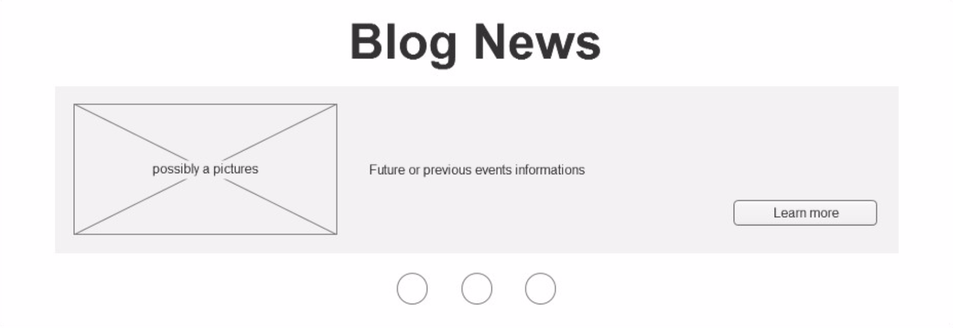

Anna Klitgaard are going to use the website to promote the company blog about the events, which we decided to feature on the frontpage.

The section is clearly titled as ‘Blog News’ with a big centered font. Underneath the title is a box, that contains a picture frame, space for a teaser for the blog and a button to lead the user to the full blog. The button is in the lower right corner titled as ‘Learn more’. the position is chosen because of the eyes direction when reading.

Three circles are added underneath the box to illustrate that the shown blog post is one out of three, and the user can switch between them.

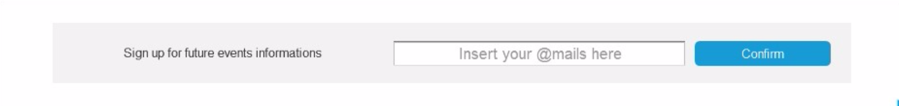

It was mentioned in a meeting with the company owner, Catarina Bettencourt, that a newsletter about the events, the company host on a monthly basis, is of high priority in the near future, so it got implemented in the wireframes.

It is located just above the footnote on the bottom of the page, because of the information flow on the frontpage. The user is getting the essential information on the upcoming event on the top of the page, and the blog section with information of the previous events afterwards, which leads up to the newsletter subscription with further information.

As the wireframe show, the user has to type in their email before pressing the button, which is shown by the fated text:’ Insert your @mail here’ inside the box.

The newsletter subscription button is one of two ‘Call to action-button’ on the page, so the button has to be clearly marked as an action, which in this case could be for example ‘Confirm’ or ‘Sign up’.



As illustrated in the wireframe, shortcuts to social medias, such as Facebook are linked through the footnote.